Fort Madison Mexican Fiesta Vendor Rental Agreement
September 17-19, 2026
Name: ______________________________________________________________________
Business Name: ______________________________________________________________
Mailing Address: _____________________________________________________________
Cell phone: _____________________________ Email: ______________________________
ONE SPACE IS 10FT x 10FT. IF YOU NEED MORE THAN ONE SPACE YOU WILL NEED TO PURCHASE MORE SPACE.
(Example: Food truck or trailer = 1 space with electricity and 1 space without electricity = $150 + $75 = $225)
$150.00 per space – Three days WITH electricity.
How many spaces? (10ft x 10ft) _____ X $150.00 = Total: $_______
$75.00 per space - Three days WITHOUT electricity.
How many spaces? (10ft x 10ft) ____ X $75.00 = Total: $_______
- I am interested in renting a heavy-duty extension cord ($100 Deposit Required)
- I have my own extension cord
Please check the category that fits what you are selling:
- Food Vendor *SEE BELOW*
- Craft Vendor
- Other (specify)__________________

Mandatory Opening Hours | Importance of Compliance
To ensure a successful and enjoyable event for all participants, food vendors must adhere to the following operating hours:  Thursday and Friday: Food vendors must be open by 5 PM.  Saturday: Food Vendors must open by noon and open until at least 2pm.  Optional Break: If you need to close between 2 PM and 4 PM, that decision is at your discretion. | Food vendors will pay an additional $100 deposit at the time of payment for your space. Food vendors will be refunded the deposit on Saturday once the opening hour agreement has been met.  We appreciate your commitment and support. Thank you for your understanding and participation!

The vendor has read, understands, and agrees to comply with the Fort Madison Mexican Fiesta Committee vendor requirements.
Signature ________________________________________ Date _____________

Please complete this form and return it with full payment by July 1, 2026. Make checks payable to the Fort Madison Mexican Fiesta Committee.

Mail your payment to:
Fort Madison Mexican Fiesta Committee
PO Box 331
Fort Madison, Iowa, 52627

Fiesta Location: Avenue Q between 34th and 35th Streets, just off Avenue O (HWY 61).

If you have any questions, please call or text Angela Salazar at 319.245.0001 or Jesse Burgher at 319.470.3801 or send an email to FortMadisonMexicanFiesta@gmail.com.

105th Fort Madison Mexican Fiesta Vendor Requirments
- All vendors are required to clearly post their operating hours at their booth or stand. This ensures that visitors are well-informed and helps maintain a smooth flow of activities throughout the event.
- Full payment is required by July 1, 2026. If we do not receive payment and have not heard from you, the reservation will be canceled. No refunds will be issued after August 1, 2026.
- You will be notified by text or email on September 15th of your space number. You will be able to begin setup on September 15th after 3pm. Vendor spaces will be clearly numbered.
- Vendors will bundle the trash and deposit in the trash barrels by their space or next to the barrel when it fills up. Volunteers will pick up the trash as needed and before opening in the morning. Please clear and clean tables routinely during service hours.
- Vehicles will not be allowed on Avenue Q after 10 AM on September 17, 18, and 19. No exceptions! Please restock early!
- All trailers and tents must be removed by Monday, September 21, 2026, as mandated by the City of Fort Madison. Failure to comply will result in a fine of $25.00 per day until the tent or trailer is removed and the area is cleaned up.
- Stink bombs and fireworks are not allowed at this event.
- No explicit merchandise will be sold or distributed at the fiesta, as this is a family-friendly event.
- No aerosol hair color will be permitted for sale or giveaway.
- Merchandise that could be categorized as a weapon will not be allowed.
- The Fort Madison Mexican Fiesta is not responsible for lost, stolen, broken, or damaged property.
- The Fort Madison Mexican Fiesta asserts its exclusive right to be the only vendor of merchandise representing the Fort Madison Mexican Fiesta celebration (such as t-shirts, koozies, etc.).
- Vendors must bring their own heavy-duty extension cords with a minimum gauge of 10. Each vendor space has one outlet, and additional outlets may be available after check-in. If you are unable to provide your own extension cords, they can be rented during the fiesta for a refundable deposit, provided they are returned in good condition. Due to limited availability, please check the box if you wish to rent one, and a committee member will contact you prior to the event.
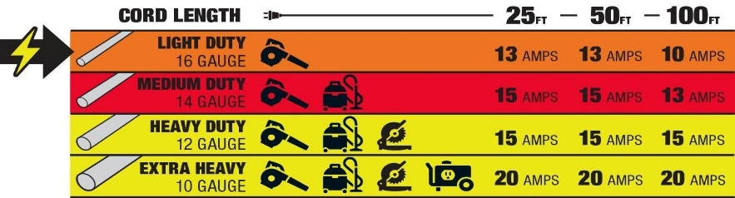
- Circuit breakers will be clearly labeled, and each receptacle is equipped with its own 30-amp breaker. To give you an idea of power usage: an average microwave consumes between 600 and 1,200 watts, which translates to 5 to 10 amps at 120 volts. A 60-watt incandescent light bulb operating at 120 volts draws approximately 0.5 amps. A crock pot typically pulls between 0.6 amps and 2 amps at 120 volts, depending on the heat setting. Roaster ovens draw 10 to 12 amps, while hot plates can draw between 8 and 12 amps, also depending on their settings. If a circuit breaker trips, it will need to be reset at the power source. Use of the inappropriate gauge and/or length of extension cord may result in a fire or electrocution or repeated breaker tripping.
- Vendors are assigned a booth space by the Fort Madison Mexican Fiesta Committee at such location as the committee may determine. The Fort Madison Mexican Fiesta Committee reserves the right to reassign booth locations to the operators of food booths at any time during the Fiesta.
- The vendor shall maintain the booth and the surrounding area in conformity with all applicable sanitary and health laws and regulations and shall also keep the booth and the surrounding area neat, clean, and free of accumulated refuse and debris. The Fort Madison Mexican Fiesta shall provide trash receptacles for use by the public throughout the festival area.
- The Vendor is responsible for properly disposing of all refuse and debris (gray water, grease, etc.) arising from any of the activities conducted in their booth.

